**Validations in Productions**

The Production Entry Process in DSS includes two steps.

Creating production data for the particular date range

Entering individual production numbers for the created production.

**Creating production data for the particular date range**

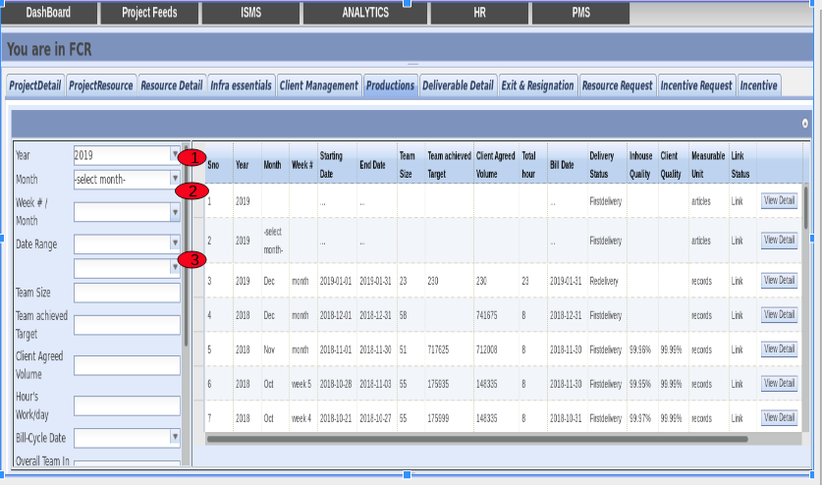

**Validations**

* Fill the mandatory fields.
* Select the year.
* Select the month.
* Select the date range
* End date should be greater than or equal to start date.

**Entering individual production numbers for the created production**

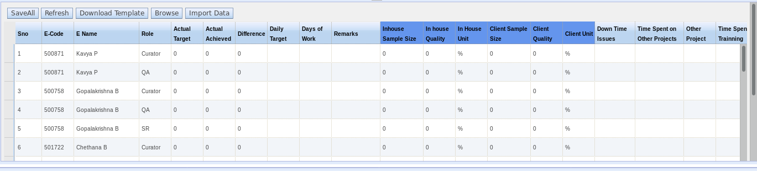

**Validations on template:-**

1. New employees should not be added directly in the template. They should be added in Resource Detail which will be automatically picked up in template.
2. No resource should be deleted in the template. If there is no contribution from a resource, it can be marked as zero.
3. All the resources present in the template should also present in **Resource Details** for that particular month.

**Notes:**-

* Download fresh template before entering production data every time.